Puppet Master and Client Installation steps

====================================================

Note: run all these commands from root. If you are running from other users you need to use #sudo <command>

Change machine hostnames like bellow

Server hostname change:

# view /etc/hostname (**Don’t copy # from this line. You need to take command line only not #**)

Add “server.example.com” and close the file

After adding press escape, colun, wq!

:wq! (to save and quit)

Do it on client machine also.

#view /etc/hostname

Add “client.example.com” and close the file

Get the eth0 IP information from both server and client using bellow command

#ifconfig eth0

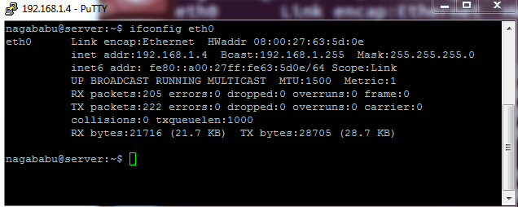

Add Ip address and hostname in “/etc/hosts” file like below on both client and server machines.

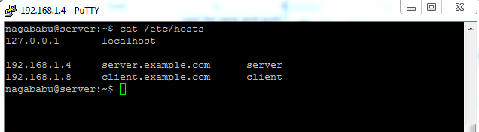

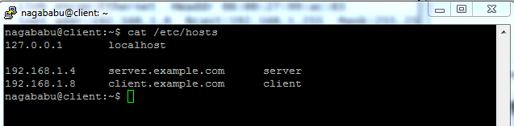

Now we need to make sure that both server and client should sync same time.

Run bellow commands from **root** user

# ntpdate pool.ntp.org ; apt-get update && sudo apt-get -y install ntp ; service ntp restart

**Puppet master installation**

To install Puppet master we need latest repository and install the Puppet as follows:

# cd /tmp  
# wget https://apt.puppetlabs.com/puppetlabs-release-trusty.deb  
# dpkg -i puppetlabs-release-trusty.deb  
# apt-get update

# apt-get install puppetmaster

Check the puppet version as:

# puppet -V

3.8.6

We have puppet version as 3.8.6. Now we need to lock the puppet version update as this will hamper the configurations while updating the puppet. It will be done by editing the file as follows:

# view /etc/apt/preferences.d/00-puppet.pref

Add the entries in the newly created above file as:

# /etc/apt/preferences.d/00-puppet.pref

Package: puppet puppet-common puppetmaster-passenger

Pin: version 3.8*

Pin-Priority: 501

It will not update the Puppet while running updates in the system.

Next we will change the configuration file as follows:

# view /etc/puppet/puppet.conf

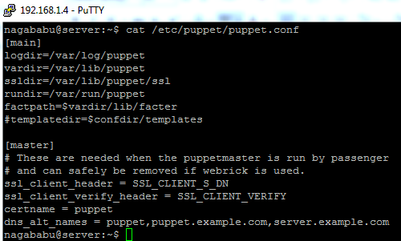

Now Restart the puppetmaster service

# service puppetmaster restart

Now the puppet master server is ready.

### Puppet client installation

In above steps we have already configured /etc/hosts file and in stalled ntp packages. Now we are going to install puppet client package and configure puppet.conf for client

#cd /tmp  
#wget https://apt.puppetlabs.com/puppetlabs-release-trusty.deb  
#dpkg -i puppetlabs-release-trusty.deb  
#apt-get update

To install client package:

#apt-get install puppet

Check the puppet version as:

#puppet -V

3.8.6

Now we need to lock the puppet version using bellow steps

Create bellow file

#view /etc/apt/preferences.d/00-puppet.pref

Add the entries in the newly created file as:

# /etc/apt/preferences.d/00-puppet.pref

Package: puppet puppet-common puppetmaster-passenger

Pin: version 3.8*

Pin-Priority: 501

It will not update the Puppet while running updates in the system.

Next we will change the configuration file as follows:

#view /etc/puppet/puppet.conf

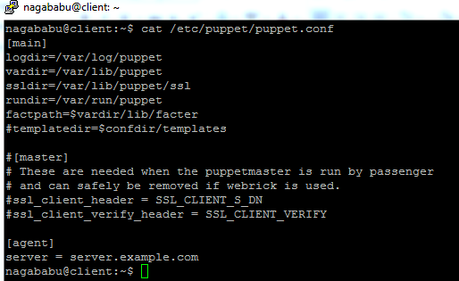

Next we need to edit the file vi /etc/default/puppet and make changes from no to yes as shown below:

#view /etc/default/puppet

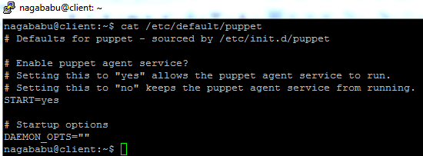

Now we are ready to start the puppet service, it will be done as follows:

#service puppet start

Now our client machine is ready to communicate with Puppet Master server.

### Cert exchange from Puppet master to puppet client

After the successful configuration Puppet client Ubuntu Desktop will search Puppet master Server and ask for cert request before accepting any administrative instructions from Master puppet server.

To view such cert request run the command at Puppet Master Ubuntu server.

# puppet cert list

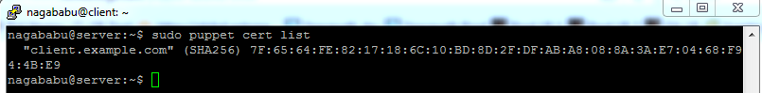

It means that there is a machine named as client.example.com which came into existence and asking for cert request. Now the puppet master server must sign the cert requested from puppet client. It can be done as follows:

# puppet cert sign client.example.com

The output will be like this:

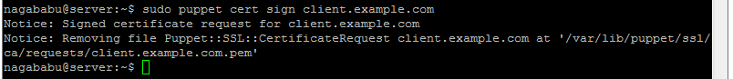

It means the request from client machine is accepted at Puppet master machine. We can check that with command as well:

# puppet cert list –all

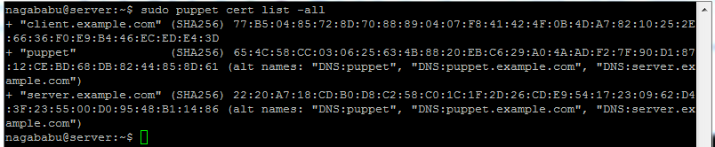

The above + sign in the output shows successful certificate signing at Puppet master Ubuntu Server.

Similarly we can add any number of clients with Puppet master Ubuntu Server and sign the cert requests from the clients.

=====================================================================

**Note: Don’t run this now. Only run when you need to remove client certification from master**

If for any administrative requirement you wish to revoke the certs from the Puppet master Ubuntu Server we can run:

# puppet cert clean client.example.com

=====================================================================================